LAB 1: PROCESS SCHEDULING ALGORITHM
- OBJECTIVE:
To maximize the CPU utilization and throughput through fair and efficient resource allocation

- PROGRAMMING LANGUAGE USED:
GOLANG

- IDE USED:
VISUAL STUDIO CODE

- THEORY:
Process Scheduling is an essential OS mechanism that manages how the CPU is allocated among the competing processes. Since a CPU core can only execute one task at once, the Process Scheduling acts as the regulator, switching the CPU rapidly between processes to maximize the Hardware utilization and create the illusion that CPU has achieved the “Parallelism” which it hasn’t technically.
This behavior or mechanism of process scheduling is categorized into two principle types:
- Preemptive: OS can interrupt a Process in mid execution
- Non-Preemptive: OS can’t interrupt a process until its completed
Based on these two principles, there are 5 types of Process Scheduling Algorithms that will be performed in this lab session:
- First Come First Serve (FCFS)[Non-Preemptive]
- Shortest Job First (SJF) [Non- Preemptive]
- Shortest Remaining Time Next (SRTN) [Preemptive version of SJF]
- Round Robin (RR) [Preemptive]
- Priority Scheduling [Preemptive/Non-Preemptive]

IMPLEMENTATION:
Q.1. Perform FCFS Process Scheduling algorithm
ALGORITHM
- The algorithm for the FCFS process Scheduling Algorithm is:
- Input the number of process and read each process’s Arrival and Burst Time
- Assign Process IDs sequentially to each process
- Sort all of the process in ascending order according to the Arrival Time
- Initialize “current-Time=0” and set total waiting time and Turn-around time to 0 as of now.
- For each process in the Sorted Order:
If current time < Arrival Time, update Current Time=Arrival Time:
Completion Time = current Time + Burst Time
Turn Around Time = Completion Time – Arrival Time
Waiting Time = Turn Around Time – Burst Time
- Update the current Time to the process’s completion time and add the waiting and turn Around time to totals
- Compute and display the average Waiting time and average Turn Around time

BLOCK DIAGRAM:

SOURCE CODE:
package main
import (
"fmt" //for the formatting purpose
"sort" // for sorting the process by arrival time //
)
type Process struct {
ID int
ArrivalTime int
BurstTime int
CompletionTime int
WaitingTime int
TurnAroundTime int
}

func main() {
var numProcess int
fmt.Println("Enter the Number of the processes you need:\n")
_, err := fmt.Scanln(&numProcess)
if err != nil {
fmt.Println("\nInvalid input. Enter the +ve number")
return
}

processes := make([]Process, numProcess) //makes a slice for required no. of process
for i := 0; i < numProcess; i++ {
pid := i + 1
processes[i].ID = pid //assign the process with respective id
fmt.Printf("\n--- Process P%d ---\n", pid)
fmt.Print("Enter the Arrival time : ")
fmt.Scanln(&processes[i].ArrivalTime)

fmt.Print("Enter the Burst time : ")
fmt.Scanln(&processes[i].BurstTime)
}

//sorting according to the arrival time //
sort.Slice(processes, func(i, j int) bool {
return processes[i].ArrivalTime < processes[j].ArrivalTime
})

currentTime := 0
var totalTAT, totalWT float64
for i := 0; i < numProcess; i++ {
if currentTime < processes[i].ArrivalTime {
currentTime = processes[i].ArrivalTime
}

processes[i].CompletionTime = currentTime + processes[i].BurstTime
processes[i].TurnAroundTime = processes[i].CompletionTime - processes[i].ArrivalTime
processes[i].WaitingTime = processes[i].TurnAroundTime - processes[i].BurstTime
totalTAT += float64(processes[i].TurnAroundTime)
totalWT += float64(processes[i].WaitingTime)
currentTime = processes[i].CompletionTime
}

fmt.Println("\nPID\tArrival\tBurst\tComplete\tTurnaround\tWaiting")
fmt.Println("-----------------------------------------------------------------")
for _, p := range processes {
fmt.Printf("P%d\t%d\t%d\t%d\t\t%d\t\t%d\n",
p.ID, p.ArrivalTime, p.BurstTime, p.CompletionTime, p.TurnAroundTime, p.WaitingTime)
}
n := float64(numProcess)
fmt.Println("\nAverage Waiting Time :", totalWT/n)
fmt.Println("\nAverage Turn Around Time :", totalTAT/n)
}

OUTPUT FOR THE FCFS:
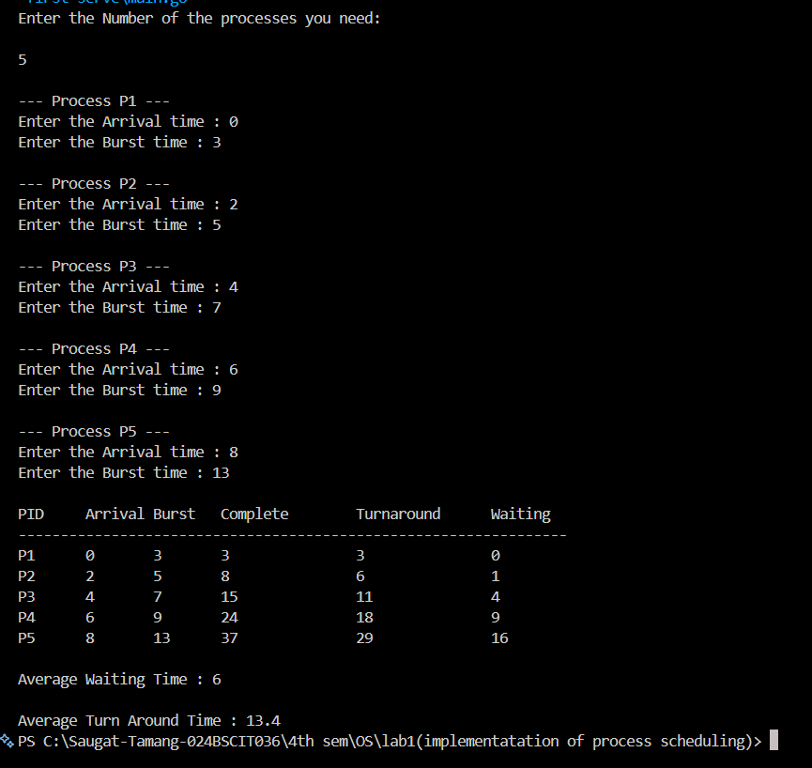

Q.2. PERFORM THE SHORTEST JOB NEXT ALGORITHM
ALGORITHM
- The algorithm for the FCFS process Scheduling Algorithm is:
- Input the number of process and read each process’s Arrival and Burst Time
- Initialize Current Time and completed Count to 0, and mark all Process as “not completed” as of this instance
- Repeat Until all of the Process is Completed:
Among all processes that arrived (Arrival Time <=Current Time) and not completed, select the process with least Burst Time
- If no process has arrived at the current Time, increment Current Time by 1 (CPU remains idle) and repeat step 3
- Execute the selected process Fully (non-preemptive) and compute:
Completion Time = current Time + Burst Time
Turn Around Time = Completion Time – Arrival Time
Waiting Time = Turn Around Time – Burst Time
- Mark the process as completed, update Current Time to its completion Time and increment the Completed Count
- Compute and display the average Waiting time and average Turn Around time

BLOCK DIAGRAM:

SOURCE CODE:
package main
import (
"fmt"
"sort"
)

type Process struct {
ID int
ArrivalTime int
BurstTime int
CompletionTime int
TurnAroundTime int
WaitingTime int
IsCompleted bool
}

func GetCredentials(numProcess int) []Process {
processes := make([]Process, numProcess)
for i := 0; i < numProcess; i++ {
pid := i + 1
processes[i].ID = pid
fmt.Printf("\n--- Process P%d ---\n", pid)
fmt.Print("Enter Arrival Time: ")
fmt.Scanln(&processes[i].ArrivalTime)
fmt.Print("Enter Burst Time: ")
fmt.Scanln(&processes[i].BurstTime)
}
return processes
}

func main() {
var numProcess int
fmt.Println("Enter the number of the processes you will need :")
_, err := fmt.Scanln(&numProcess)
if err != nil || numProcess <= 0 {
fmt.Println("Invalid Input . +ve number as the input is required.\n")
return
}
processes := GetCredentials(numProcess)
CurrentTime := 0
CompletedCount := 0
var totalWT, totalTAT float64
for CompletedCount < numProcess {
minIndex := -1 // first jpb
minBurst := 1e9 // setting to hightest so that replacing will be easier
for i := 0; i < numProcess; i++ {
if processes[i].ArrivalTime <= CurrentTime && !processes[i].IsCompleted {
if processes[i].BurstTime < int(minBurst) {
minBurst = float64(processes[i].BurstTime)
minIndex = i
}
}
}

//when no processes arrive and cpu is in the idle condition
if minIndex == -1 {
CurrentTime++
continue
}
idx := minIndex
processes[idx].CompletionTime = CurrentTime + processes[idx].BurstTime
processes[idx].TurnAroundTime = processes[idx].CompletionTime - processes[idx].ArrivalTime
processes[idx].WaitingTime = processes[idx].TurnAroundTime - processes[idx].BurstTime
processes[idx].IsCompleted = true
totalTAT += float64(processes[idx].TurnAroundTime)
totalWT += float64(processes[idx].WaitingTime)
// Advance currentTime to when this process finishes
CurrentTime = processes[idx].CompletionTime
CompletedCount++
}
sort.Slice(processes, func(i, j int) bool {
return processes[i].ID < processes[j].ID
})
// 5. Output the results
fmt.Println("\nPID\tArrival\tBurst\tComplete\tTurnaround\tWaiting")
fmt.Println("-----------------------------------------------------------------")
for _, p := range processes {
fmt.Printf("P%d\t%d\t%d\t%d\t\t%d\t\t%d\n",
p.ID, p.ArrivalTime, p.BurstTime, p.CompletionTime, p.TurnAroundTime, p.WaitingTime)
}
n := float64(numProcess)
fmt.Printf("\nAverage Turnaround Time: %.2f\n", totalTAT/n)
fmt.Printf("Average Waiting Time: %.2f\n", totalWT/n)
}

OUTPUT FOR THE SHORTEST JOB NEXT:

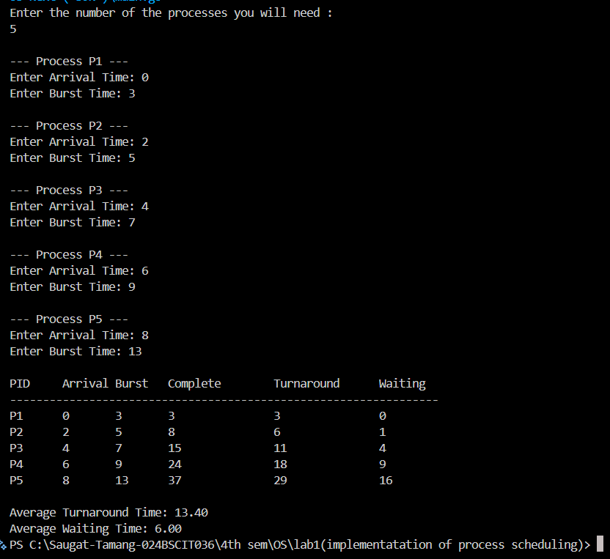

Q.3. PERFORM THE SHORTEST REMAINING TIME NEXT ALGORITHM
- The algorithm for SRTN algorithm is given below:
- Input the number of processes and read each process’s Arrival Time and Burst Time, assigning a unique Process ID.
- Initialize RemainingTime = BurstTime for each process, and set currentTime = 0, completedCount = 0.
- Repeat until all processes are completed:
- Among all processes that have arrived (ArrivalTime ≤ currentTime) and have RemainingTime > 0, select the process with the minimum remaining time.
- If no process is available, increment currentTime by 1 (CPU remains idle) and continue.
- Execute the selected process for exactly one time unit (preemptive execution) by decrementing its RemainingTime by 1.
- If a process’s remaining time becomes zero, mark it as completed and calculate:
Completion Time = currentTime + 1
Turnaround Time = Completion Time − Arrival Time
Waiting Time = Turnaround Time − Burst Time
- Increment currentTime after each time unit, and after all processes finish, compute the average Waiting Time and average Turnaround Time.

BLOCK DIAGRAM:

SOURCE CODE:
package main

import (
"fmt"
"sort"
)
type Process struct {
ID int
ArrivalTime int
BurstTime int
RemainingTime int // this is the crucial part of SRTN
CompletionTime int
TurnAroundTime int
WaitingTime int
}
func main() {
var numProcess int
fmt.Println("Enter the number of the Processes you will need:")
_, err := fmt.Scanln(&numProcess)
if err != nil || numProcess <= 0 {
fmt.Println("Invalid input. Exiting.")
return
}
processes := make([]Process, numProcess)
for i := 0; i < numProcess; i++ {
pid := i + 1
processes[i].ID = pid
fmt.Println("\n----Process P%d----\n", pid)
fmt.Println("Enter the arrival time :")
fmt.Scanln(&processes[i].ArrivalTime)
fmt.Println("Enter the Burst time :")
fmt.Scanln(&processes[i].BurstTime)

//initially ,remaining time equals to the Burst Time
processes[i].RemainingTime = processes[i].BurstTime
}
currentTime := 0
completedCount := 0
var totalTAT, totalWT float64
for completedCount < numProcess {
minIndex := -1
minRemaining := 1e9
for i := 0; i < numProcess; i++ {
if processes[i].ArrivalTime <= currentTime && processes[i].RemainingTime > 0 {
if float64(processes[i].RemainingTime) < minRemaining {
minRemaining = float64(processes[i].RemainingTime)
minIndex = i
}
}
if minIndex == -1 {
currentTime++
continue
}
processes[i].RemainingTime--
}
if processes[minIndex].RemainingTime == 0 {
completedCount++
idx := minIndex
processes[idx].CompletionTime = currentTime + 1 //
processes[idx].TurnAroundTime = processes[idx].CompletionTime - processes[idx].ArrivalTime
processes[idx].WaitingTime = processes[idx].TurnAroundTime - processes[idx].BurstTime

totalTAT += float64(processes[idx].TurnAroundTime)
totalWT += float64(processes[idx].WaitingTime)

}
currentTime++
}
sort.Slice(processes, func(i, j int) bool {
return processes[i].ID < processes[j].ID
})
// 5. Output the results table
fmt.Println("\nPID\tArrival\tBurst\tComplete\tTurnaround\tWaiting")
fmt.Println("-----------------------------------------------------------------")
for _, p := range processes {
fmt.Printf("P%d\t%d\t%d\t%d\t\t%d\t\t%d\n",
p.ID, p.ArrivalTime, p.BurstTime, p.CompletionTime, p.TurnAroundTime, p.WaitingTime)
}

n := float64(numProcess)
fmt.Printf("\nAverage Turnaround Time: %.2f\n", totalTAT/n)
fmt.Printf("Average Waiting Time: %.2f\n", totalWT/n)
}

OUTPUT FOR THE SHORTEST REMAINING TIME NEXT:

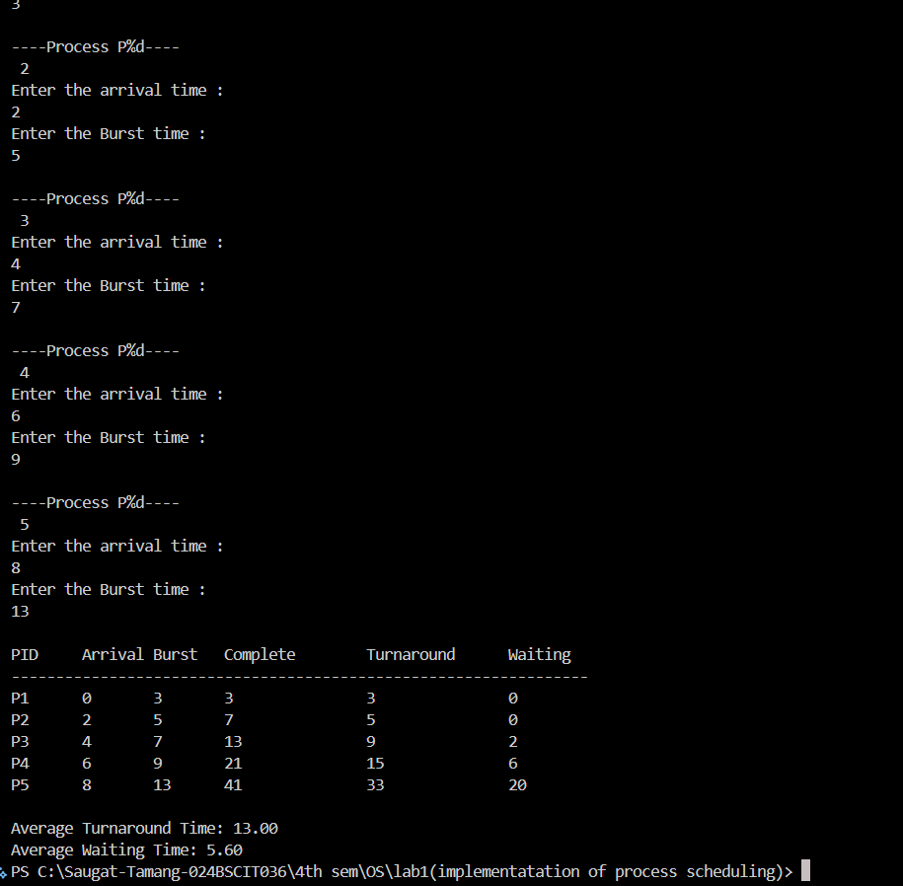

Q.4. PERFORM THE ROUND ROBIN ALGORITHM

ALGORITHM
- The algorithm for the RR algorithm is given below:
- Input the number of processes, their Arrival Time, Burst Time, and the Quantum Time; unique to each process
- Initialize each process’s Remaining Time = Burst Time, set currentTime = 0, completedCount = 0, and sort processes by Arrival Time.
- Insert into the ready queue all processes whose Arrival Time equals the current time, marking them as InQueue.
- While not all processes are completed:
If the ready queue is empty, increment currentTime by 1 and enqueue any newly arrived process
- Dequeue the first process from the ready queue and execute it for min(time quantum, remaining time )
- Update currentTime, decrease the process’s Remaining Time, and enqueue any processes that arrive during execution.
- If the process is completed, compute Completion, Turnaround, and Waiting Time; otherwise, enqueue it back to the end of the ready queue. Repeat until all processes finish.

BLOCK DIAGRAM:

SOURCE CODE:

package main

import (
"fmt"
"sort"
)

type Process struct {
ID int
ArrivalTime int
BurstTime int
RemainingTime int
CompletionTime int
TurnAroundTime int
WaitingTime int
InQueue bool
}

func main() {
var numProcess, quantum int
fmt.Println("Enter the total number of the processes:")
fmt.Scanln(&numProcess)
processes := make([]Process, numProcess)

for i := 0; i < numProcess; i++ {
pid := i + 1
processes[i].ID = pid
fmt.Println("Enter the Arrival Time :")
fmt.Scanln(&processes[i].ArrivalTime)
fmt.Println("Enter the Burst Time:")
fmt.Scanln(&processes[i].BurstTime)
processes[i].RemainingTime = processes[i].BurstTime
}

fmt.Println("\nEnter the Time Quantum :")
fmt.Scanln(&quantum)

sort.Slice(processes, func(i, j int) bool {
return processes[i].ArrivalTime < processes[j].ArrivalTime
})

var readyQueue []int
currentTime := 0
completedCount := 0
var totalTAT, totalWT float64

for i := 0; i < numProcess; i++ {
if processes[i].ArrivalTime == currentTime {
readyQueue = append(readyQueue, i)
processes[i].InQueue = true
}
}

for completedCount < numProcess {
if len(readyQueue) == 0 {
currentTime++
for i := 0; i < numProcess; i++ {
if processes[i].ArrivalTime <= currentTime && processes[i].RemainingTime > 0 && !processes[i].InQueue {
readyQueue = append(readyQueue, i)
processes[i].InQueue = true
}
}
continue
}

idx := readyQueue[0]
readyQueue = readyQueue[1:]

executionTime := quantum
if processes[idx].RemainingTime < executionTime {
executionTime = processes[idx].RemainingTime
}

currentTime += executionTime
processes[idx].RemainingTime -= executionTime

for i := 0; i < numProcess; i++ {
if processes[i].ArrivalTime <= currentTime && processes[i].RemainingTime > 0 && !processes[i].InQueue {
readyQueue = append(readyQueue, i)
processes[i].InQueue = true
}
}

if processes[idx].RemainingTime > 0 {
readyQueue = append(readyQueue, idx)
} else {
completedCount++
processes[idx].CompletionTime = currentTime
processes[idx].TurnAroundTime = processes[idx].CompletionTime - processes[idx].ArrivalTime
processes[idx].WaitingTime = processes[idx].TurnAroundTime - processes[idx].BurstTime

totalTAT += float64(processes[idx].TurnAroundTime)
totalWT += float64(processes[idx].WaitingTime)
}
}

sort.Slice(processes, func(i, j int) bool {
return processes[i].ID < processes[j].ID
})

fmt.Println("\nPID\tArrival\tBurst\tComplete\tTurnaround\tWaiting")
fmt.Println("-----------------------------------------------------------------")
for _, p := range processes {
fmt.Printf("P%d\t%d\t%d\t%d\t\t%d\t\t%d\n",
p.ID, p.ArrivalTime, p.BurstTime, p.CompletionTime, p.TurnAroundTime, p.WaitingTime)
}

n := float64(numProcess)
fmt.Printf("\nAverage Turnaround Time: %.2f\n", totalTAT/n)
fmt.Printf("Average Waiting Time: %.2f\n", totalWT/n)
}

OUTPUT FOR ROUND ROBIN (RR) :
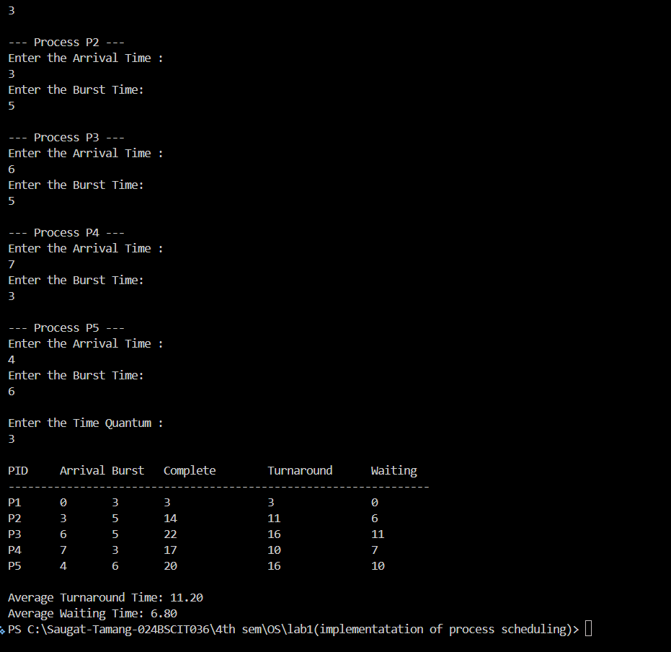

Q.5 PERFORM THE PRIORITY PREEMPTIVE
ALGORITHM:
- The Algorithm for the Priority Preemptive algorithm is given below:
- Input the number of processes and read each process’s Arrival Time, Burst Time, and Priority, assigning a unique Process ID (lower priority number indicates higher priority).
- Initialize each process’s Remaining Time = Burst Time, and set currentTime = 0, completedCount = 0.
- Repeat until all processes are completed :
Among all processes that have arrived (ArrivalTime ≤ currentTime) and have RemainingTime > 0, select the process with the highest priority (smallest priority value).
- If no process is available, increment currentTime by 1 (CPU remains idle) and repeat the selection step.
- Execute the selected process for exactly one time unit (preemptive execution) by decrementing its Remaining Time by 1 and advancing currentTime.
- If the process finishes execution (RemainingTime =0),compute:
Completion Time = currentTime
Turnaround Time = completion time – Arrival Time
Waiting Time = Turn Around time – burst time , and increment completedCount
- After all processes finish, calculate and display the average Waiting Time and average Turnaround Time.

BLOCK DIAGRAM:

SOURCE CODE:

package main

import (
"fmt"
"sort"
)
type Process struct {
ID int
ArrivalTime int
BurstTime int
RemainingTime int
Priority int // Lower integer means higher priority
CompletionTime int
TurnaroundTime int
WaitingTime int
}

func main() {
var numProcesses int

// 1. Collect Input from User
fmt.Print("Enter the total number of processes: ")
_, err := fmt.Scanln(&numProcesses)
if err != nil || numProcesses <= 0 {
fmt.Println("Invalid input. Exiting.")
return
}

processes := make([]Process, numProcesses)

for i := 0; i < numProcesses; i++ {
pid := i + 1
processes[i].ID = pid
fmt.Printf("\n--- Process P%d ---\n", pid)
fmt.Print("Enter Arrival Time: ")
fmt.Scanln(&processes[i].ArrivalTime)
fmt.Print("Enter Burst Time: ")
fmt.Scanln(&processes[i].BurstTime)
fmt.Print("Enter Priority (Lower number = Higher Priority): ")
fmt.Scanln(&processes[i].Priority)

// Initialize remaining time to match the initial burst time
processes[i].RemainingTime = processes[i].BurstTime
}

currentTime := 0
completedCount := 0
var totalTAT, totalWT float64

// 2. Main Preemptive Priority Simulation Loop
for completedCount < numProcesses {
highestPriorityIdx := -1
highestPriorityVal := int(1e9) // Using a large number since smaller integer = higher priority

// Scan for the arrived process with the highest priority (lowest integer value)
for i := 0; i < numProcesses; i++ {
if processes[i].ArrivalTime <= currentTime && processes[i].RemainingTime > 0 {
if processes[i].Priority < highestPriorityVal {
highestPriorityVal = processes[i].Priority
highestPriorityIdx = i
}
}
}

// CPU Idle check: if no process has arrived yet, advance the clock cleanly
if highestPriorityIdx == -1 {
currentTime++
continue
}

// --- EXECUTION WINDOW ---
// The chosen process takes exactly 1 unit of CPU time right now
processes[highestPriorityIdx].RemainingTime--
currentTime++ // The global timeline moves forward immediately by that 1 unit

// Check if the process finished *after* that time unit passed
if processes[highestPriorityIdx].RemainingTime == 0 {
completedCount++

idx := highestPriorityIdx
// Since currentTime already jumped forward by 1, it naturally reflects the true completion point
processes[idx].CompletionTime = currentTime
processes[idx].TurnaroundTime = processes[idx].CompletionTime - processes[idx].ArrivalTime
processes[idx].WaitingTime = processes[idx].TurnaroundTime - processes[idx].BurstTime

totalTAT += float64(processes[idx].TurnaroundTime)
totalWT += float64(processes[idx].WaitingTime)
}
}

// 3. Sort back by ID for structured output printing
sort.Slice(processes, func(i, j int) bool {
return processes[i].ID < processes[j].ID
})

// 4. Print Results Table
fmt.Println("\nPID\tArrival\tBurst\tPriority\tComplete\tTurnaround\tWaiting")
fmt.Println("-------------------------------------------------------------------------")
for _, p := range processes {
fmt.Printf("P%d\t%d\t%d\t%d\t\t%d\t\t%d\t\t%d\n",
p.ID, p.ArrivalTime, p.BurstTime, p.Priority, p.CompletionTime, p.TurnaroundTime, p.WaitingTime)
}

// 5. Display Averages
n := float64(numProcesses)
fmt.Printf("\nAverage Turnaround Time: %.2f\n", totalTAT/n)
fmt.Printf("Average Waiting Time: %.2f\n", totalWT/n)
}

OUTPUT FOR PRIORITY PREEMPTIVE ALGORITHM

